Assignment 3 CECS 575/675 Fall 2019 Due Oct 30, 2:00pm

1. Write an OO program to implement the FSA depicted below. You must use the State design pattern. The program must have classes for the client, context, abstract state and concrete states (6 concrete states). The – means that state is a start state (only #1) and + means the state is final (#4, #5, #6)

Submit all the code in one text, word or pdf file.

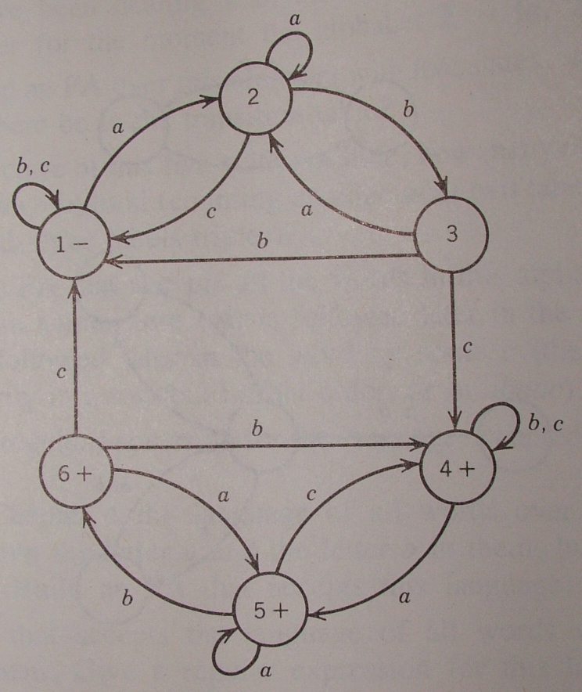

Text input and output are acceptable.

2. What words are accepted by this FSA?

